**20.5.1 gparted**

Modern systems which use the Unified Extensible Firmware Interface (UEFI) specification and GPT partitions to boot have their own graphical and command line tools for managing storage. One powerful graphical tool is the gparted tool, the GUI front end of the GNU Parted program. **Gparted (Gnome Partition Editor)** is a free, multi-platform graphical tool for managing hard disks. It works with Linux, Windows, and MacOS and allows the creation, reorganization, and deletion of system partitions. With this tool, you can resize existing partitions to make space for a new operating system, enable and disable partition flags like boot and hidden, and perform many other partitioning tasks easily with its intuitive graphical interface.

In the image below, we have a blank disk that needs to be partitioned and a filesystem created on it before it can be used (mounted) onto the system. Partitioning defines the space on the device so that it is visible to the operating system. Then, a high-level format is performed, which defines the filesystem to be used. Finally, the filesystem is mounted so that data can be written to it by the operating system.

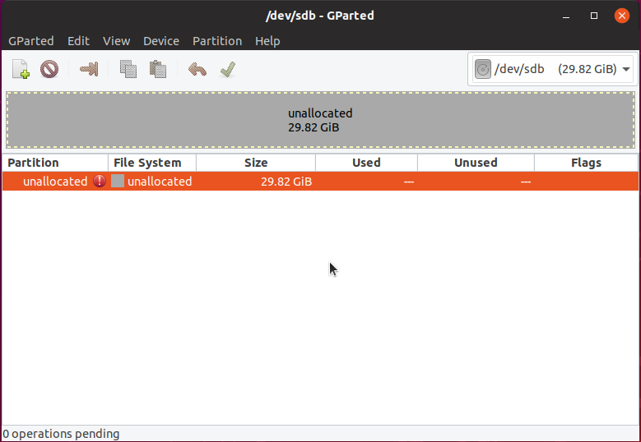

Using the gparted utility, we can create a new GPT partition table. There are several methods that can be used when creating a table. For example, a common partitioning method is making space on an existing disk to install another operating system by resizing the existing partition. In addition to performing disk management tasks, the gparted tool can also attempt recovery on a corrupted partition, and copy an existing partition for backup or image creation.

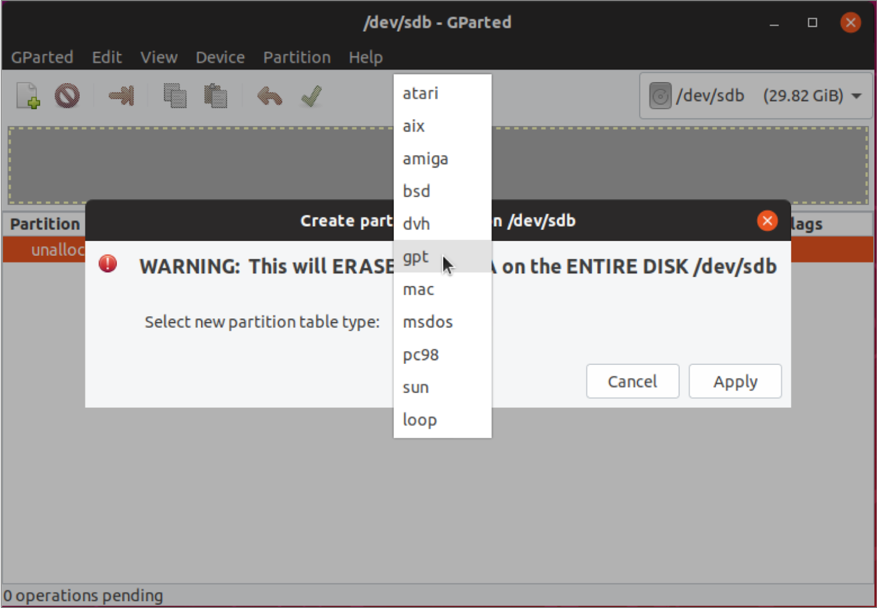

Parameters for the new partition can be entered into the dialog box such as size, name, whether it’s a primary partition (where an operating system can be installed), and filesystem type.

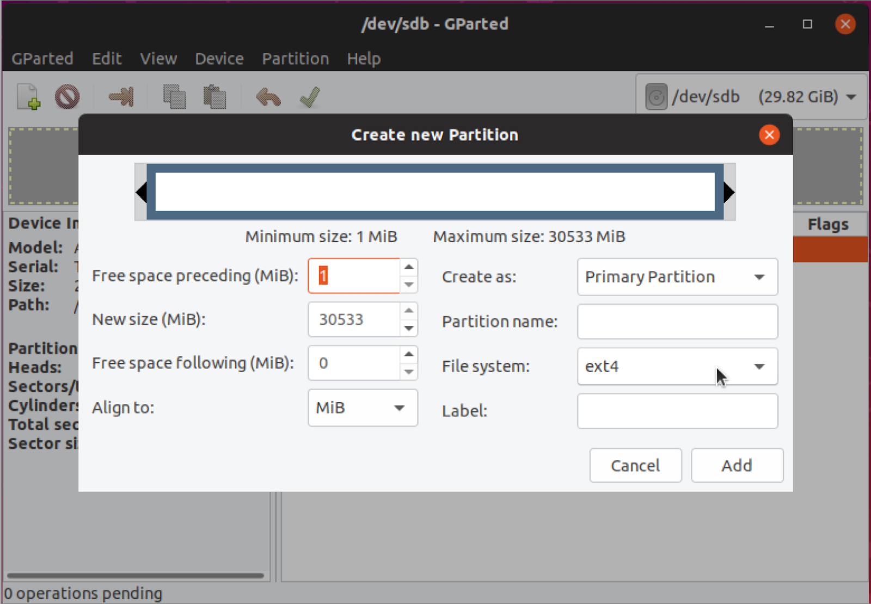

To see details about the partition to be created, you would select device information from the *View* menu. In the image below, at the bottom of the window, you can see there is one operation pending. When you click the green checkmark below the menu bar, it will perform the specified action and create the new partition. There will be a dialog confirming that you want to proceed with the action, and one confirming success.

